Ex No:6 E-TICKETING
- CLASS DIAGRAM
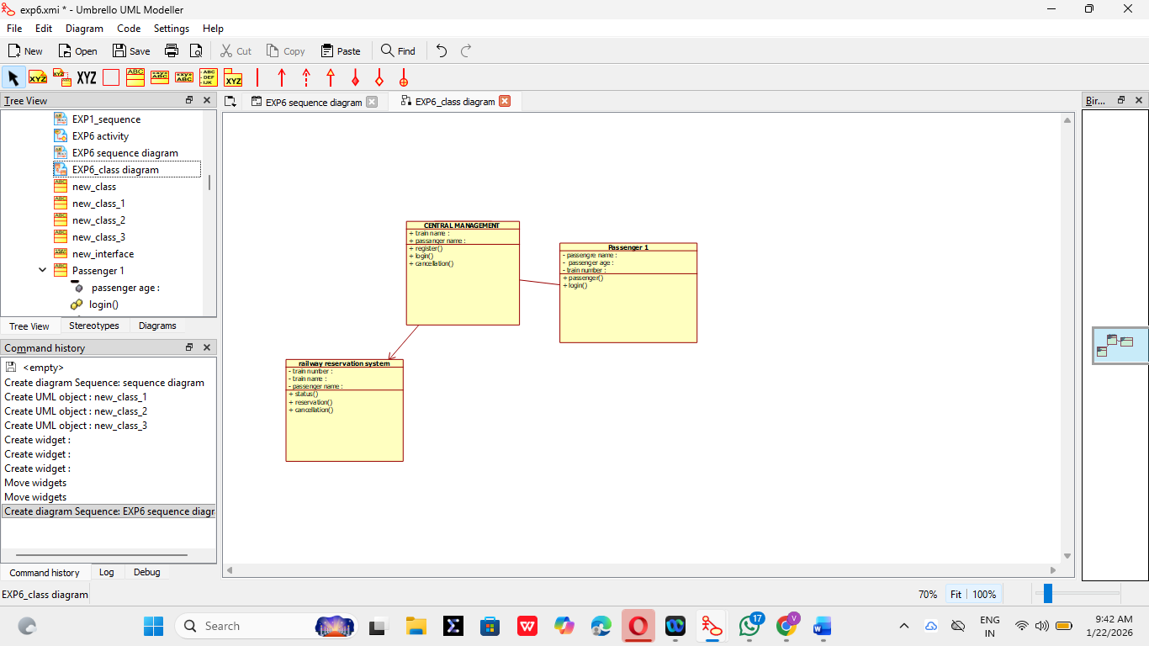

- USE CASE DIAGRAM
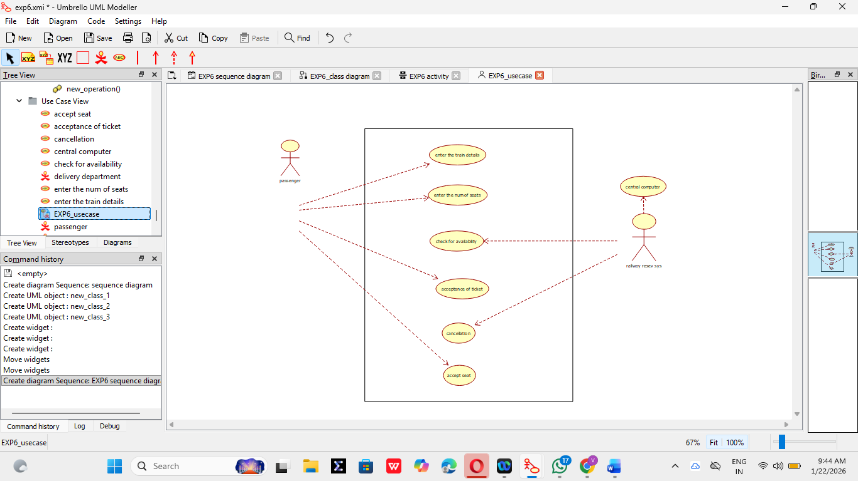

3.ACTIVITY DIAGRAM
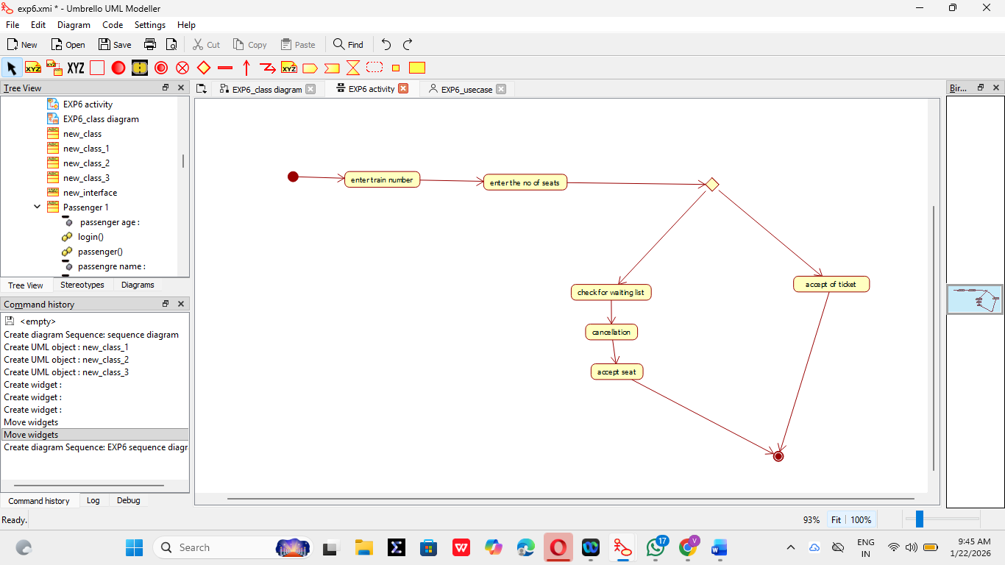
4.SEQUENCE DIAGRAM
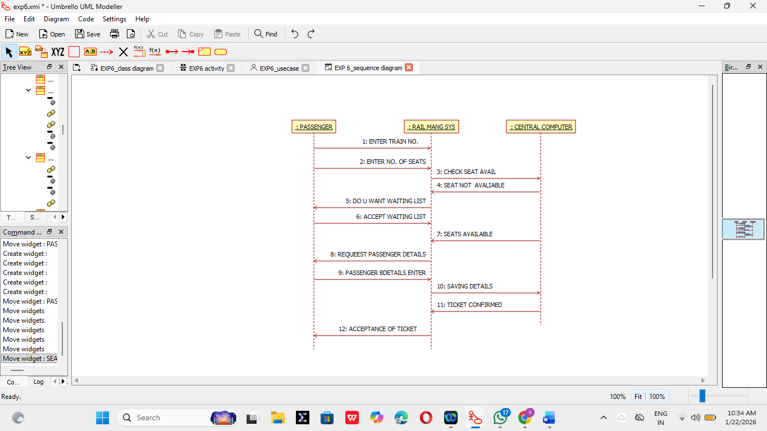

5. COLLABORATION DIAGRAM
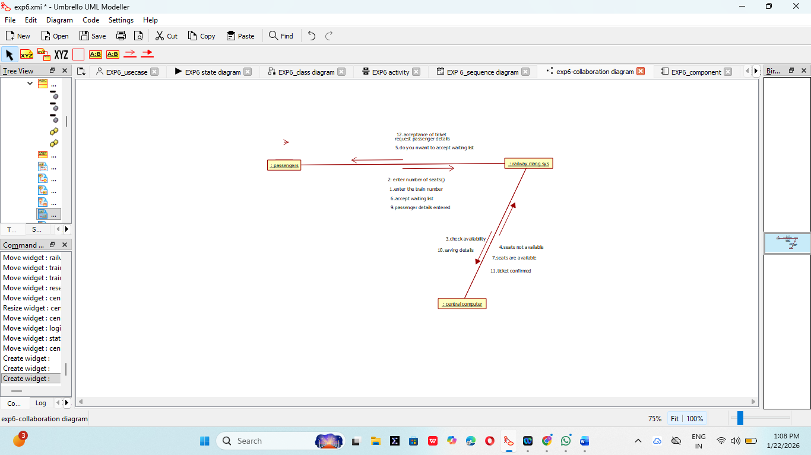

6.STATE CHART DIAGRAM
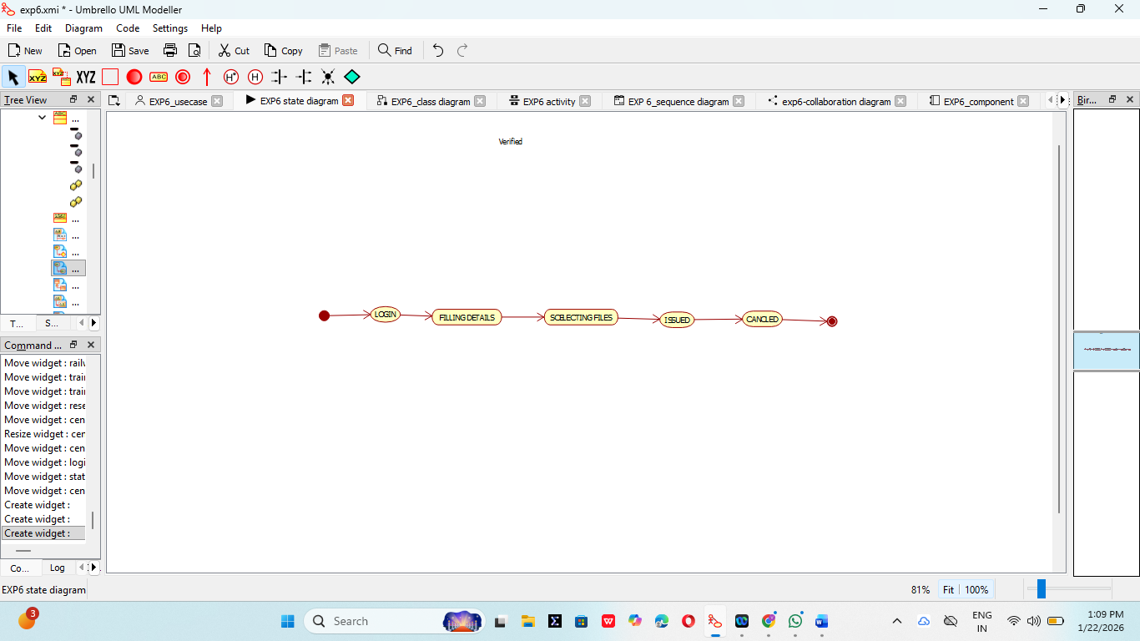

7.COMPONENT DIAGRAM
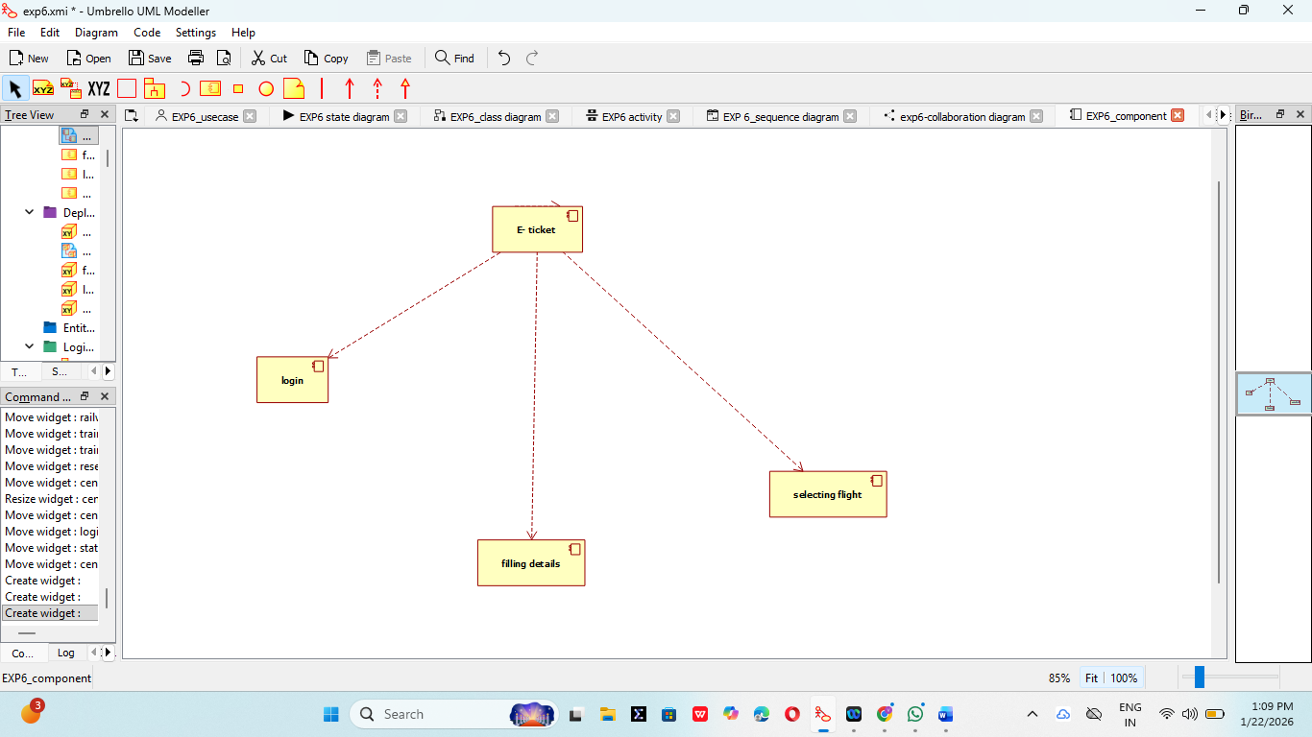

8. DEPLOYMENT DIAGRAM
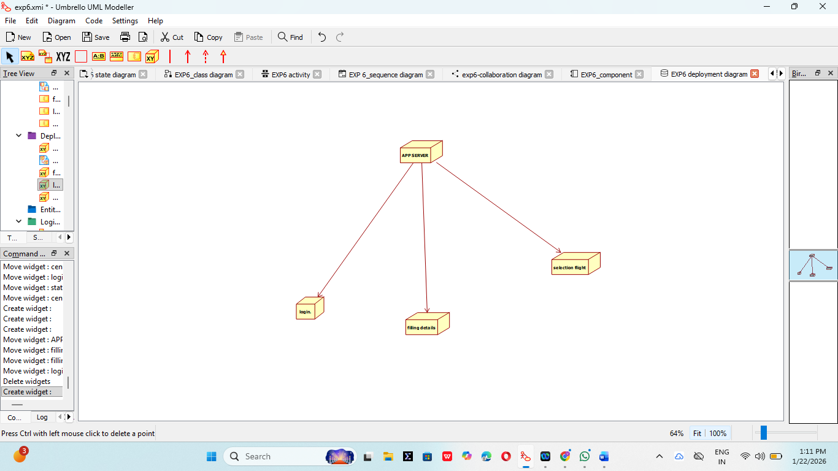

9.PACKAGE DIAGRAM
